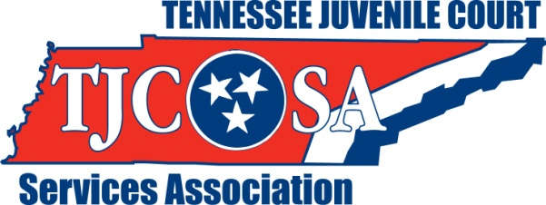
President,
Teresa Moyers
(865) 397-2906

Vice-President,
Antinio Petty
(423) 209-5108

Secretary,
Michelle Nix
(865) 397-2906

Treasurer,
Barry Fain
(865) 397-2906

To: Exhibitors/Sponsors

From: Teresa Moyers, President
Marjorie Miller, Exhibitor Chair

Date: January 24, 2014

We are proud to announce that the Thirty-first (31st) Joint Conference on Juvenile Justice will be held Sunday, August 3, 2014, through Wednesday, August 6, 2014, at the Park Vista in Gatlinburg, Tennessee.

The Tennessee Juvenile Court Services Association and the Tennessee Council of Juvenile and Family Court Judges are planning a program that will be informative and beneficial for all people involved in juvenile justice. Representatives are expected from the National Council of Juvenile and Family Court Judges as well as the National Juvenile Court Services Association.
Juvenile Justice Professionals are in constant need of knowledge regarding the modern trends in the Juvenile Justice System. Your participation as an exhibitor and/or sponsor will be extremely helpful to all conference participants in achieving this goal.

We believe this joint conference will be the single best marketing tool at your disposal this entire year. In attendance will be judges and juvenile court staff from all 95 counties across Tennessee and other states as well. Numerous state and private agencies that work with children and families will also be present. Since attendance for this conference is expected to be over 500 participants, we feel this conference will provide plenty of marketing opportunities.

If you are interested in being an exhibitor and/or sponsoring one or more conference activities such as the reception, luncheon, breakfast, coffee break, or hospitality please respond by completing and returning the attached form. You may also show your support by placing an advertisement in the conference program.

We hope that you will join us in supporting the TJCSA and the TCJFCJ 31st Annual Joint Conference on Juvenile Justice. If you have any questions or concerns, please feel free to contact Marjorie Miller at (423) 989-5554 or by email at mmiller@bristoltn.org. Thank you in advance for your support of the Thirty-First Joint Conference on Juvenile Justice. We are looking forward to seeing you in Gatlinburg.
Jefferson County Juvenile Court ♦ P.O. Box 1721 Dandridge, TN 37725 ♦ www.tjcsa.com

