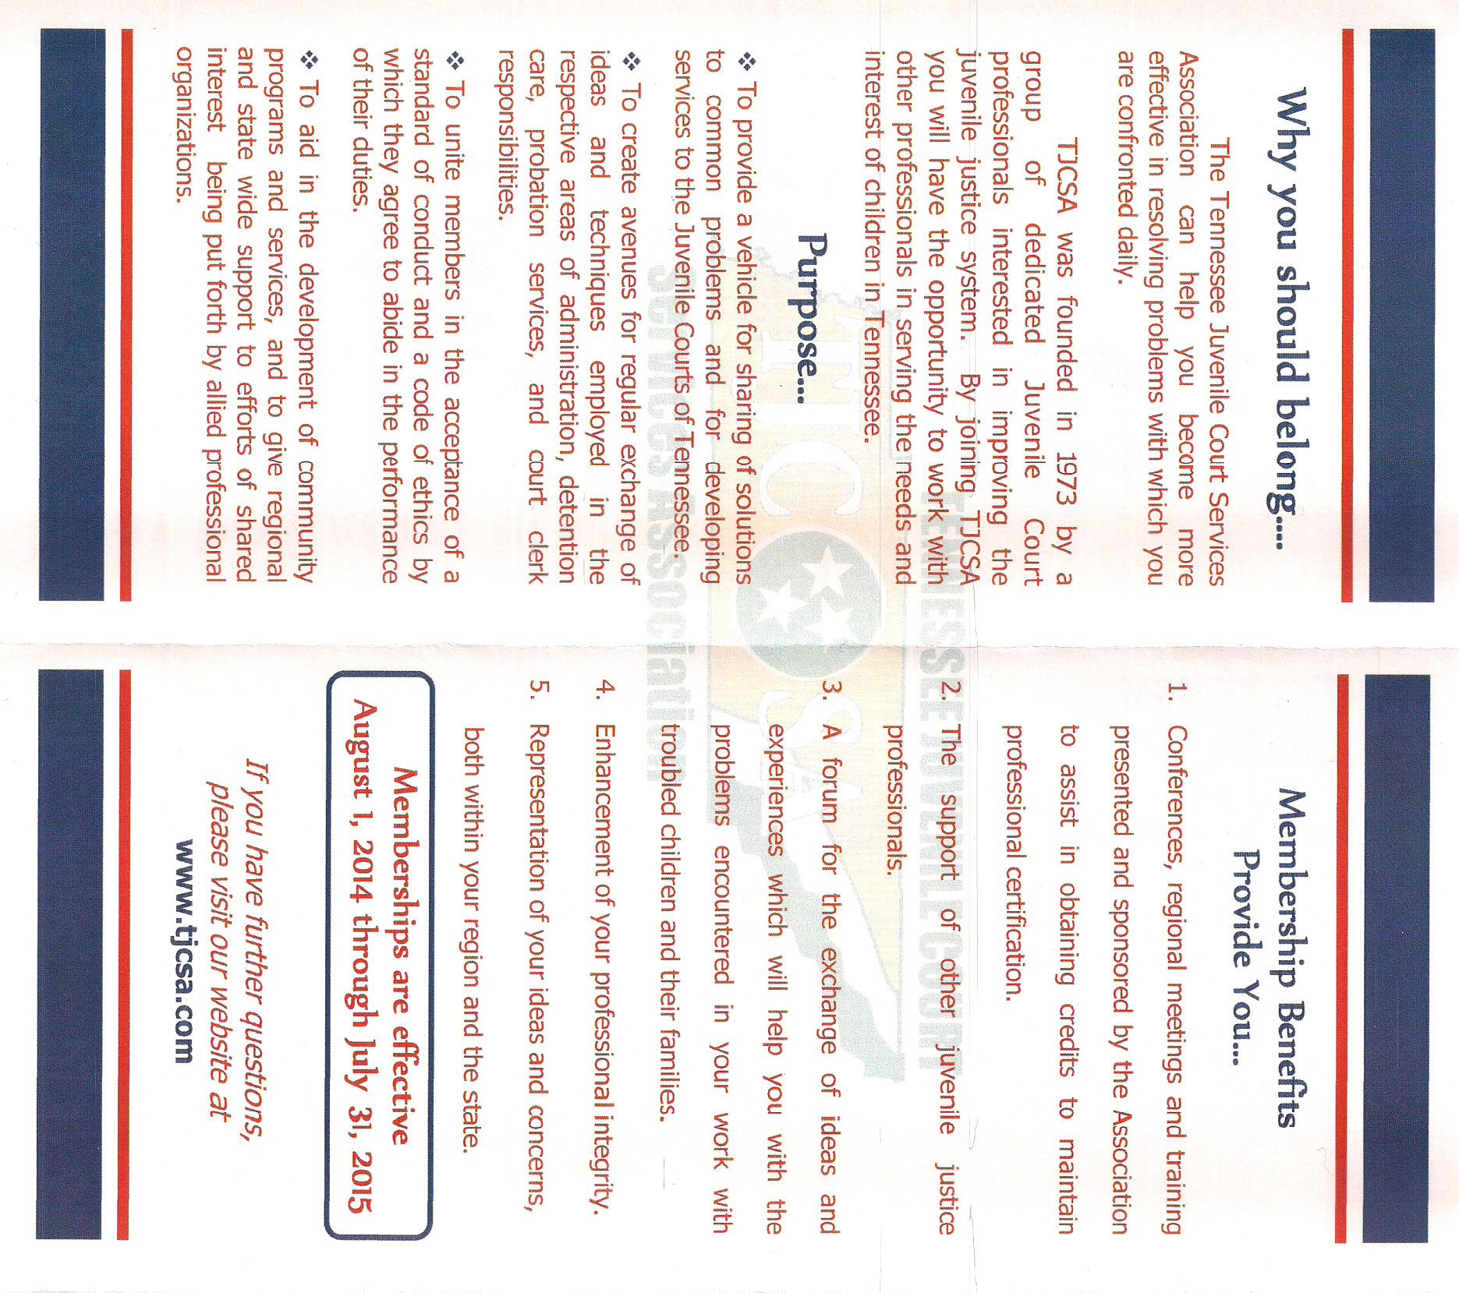
TENNESSEE JUVENILE COURT SERVICES ASSOCIATION
Regular TJCSA Membership (open only to juvenile court personnel) . . . . . . . . . .$35.00

Name: Position:
Organization:
Address:
City: State: Zip: Phone: ( )
Email: @

Mail to: Tennessee Juvenile Court Services Association
P.O. Box 1721
Dandridge, TN 37725-1721
ATTN: Barry Fain
Memberships effective August 1, 2014 through July 31, 2015


